**Lab 1: Thermal Simulation of Semiconductor Packages with ANSYS**

Open Ansys Electronics Desktop. Go to Project -> Insert Icepack Design

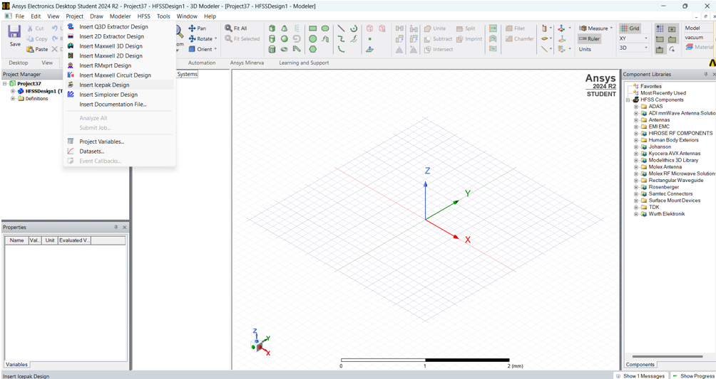

An Icepack Project will appear.

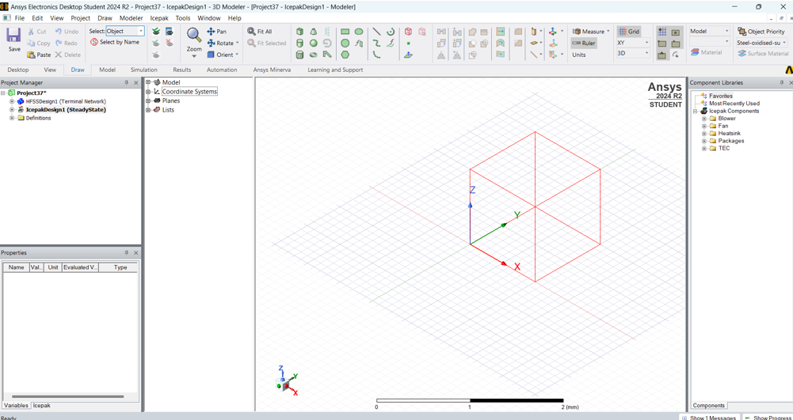

Go to Icepack -> Toolkit -> Geometry -> Packages -> FilpChip_BGA. A tiny window will appear where you can customize the dimensions of the package.

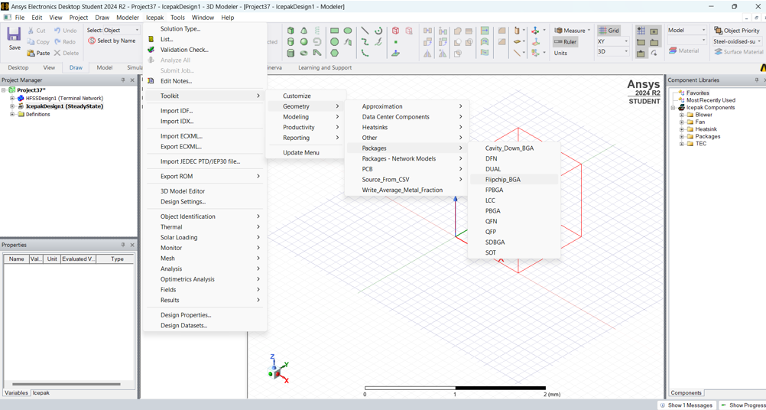

The model of the package is loaded. Go to Model to see the package.

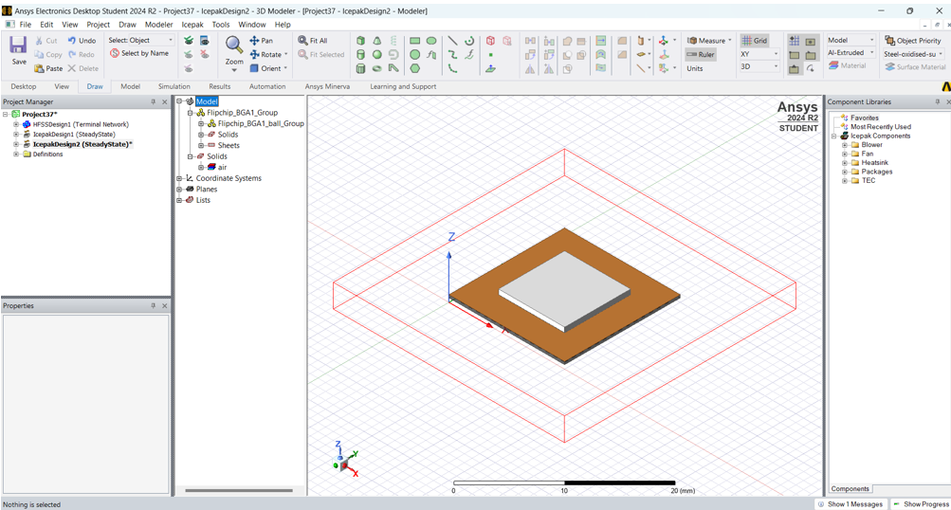

Go to Project Manager -> Thermal -> Select the Power -> OK

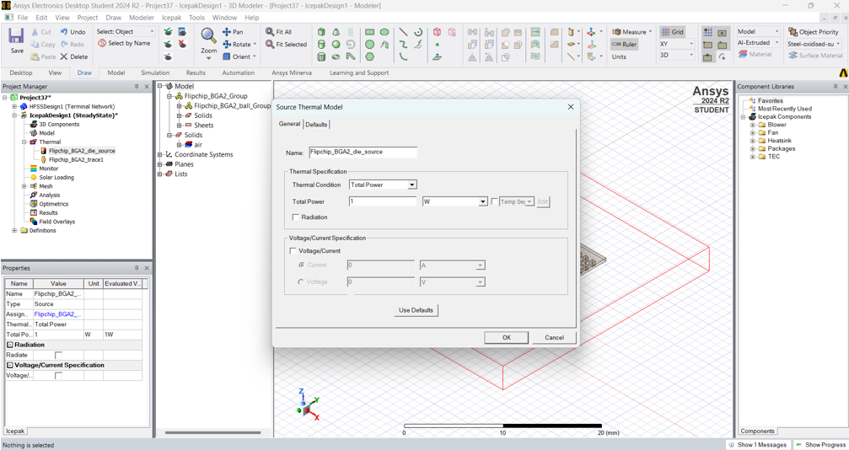

Go to solids -> Flipchip-BGA2_substrate -> Assign Thermal -> Source

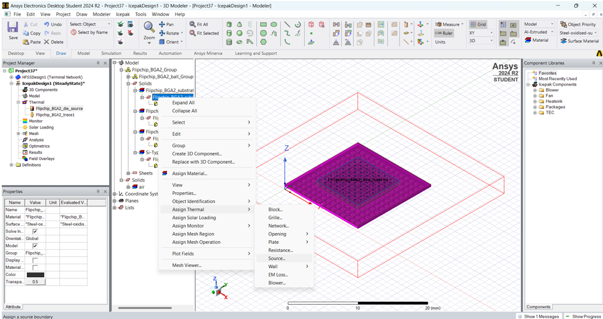

A window will pop up. Here, select Ambient Temp and Finish.

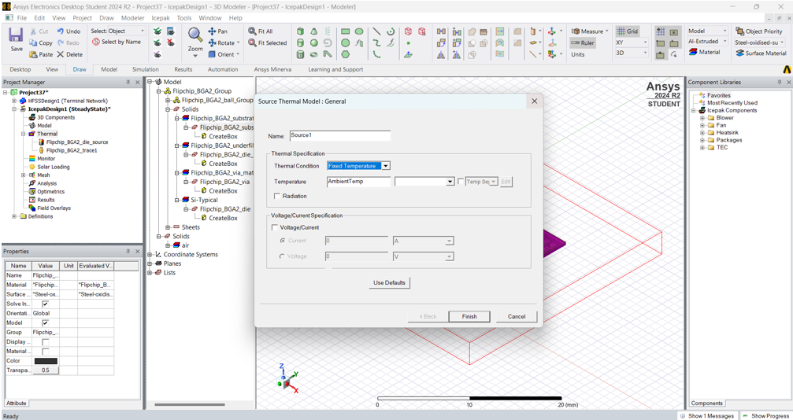

Go to solids -> Flipchip-BGA2_substrate -> Assign Monitor -> Point

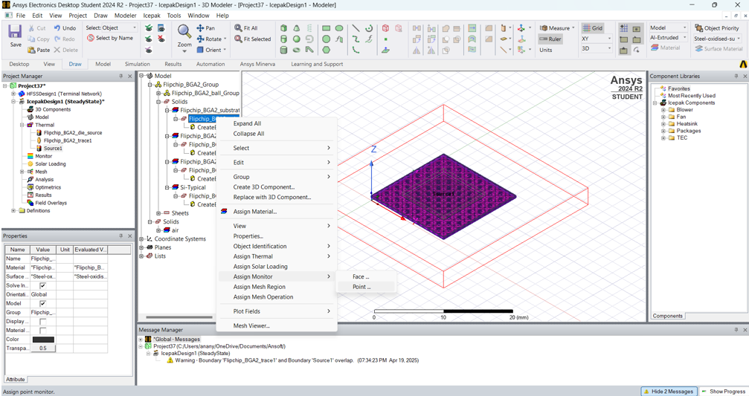

A window will pop up. Here, under Thermal select Temperature. Repeat this process for Die and Underfill also.

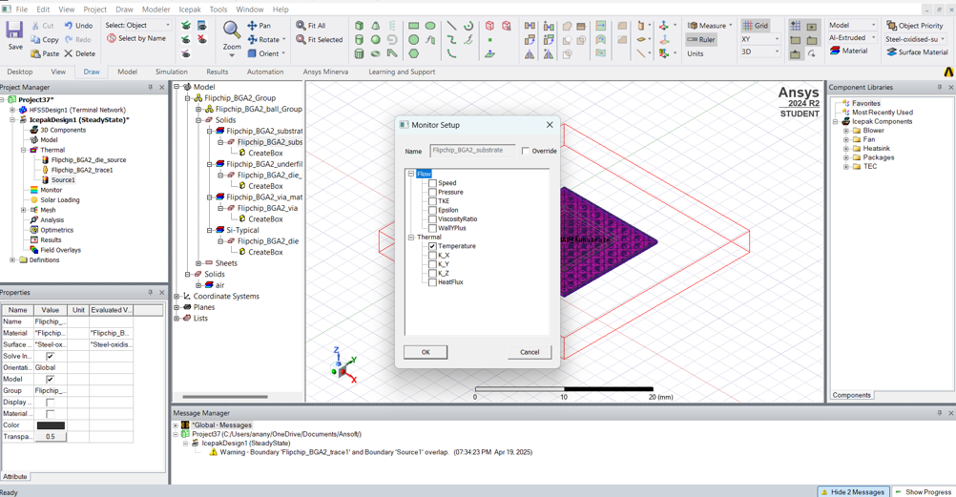

Go to Mesh -> Simulation -> Generate Mesh -> save the file -> OK. Go to Quality and click on Face alignment.

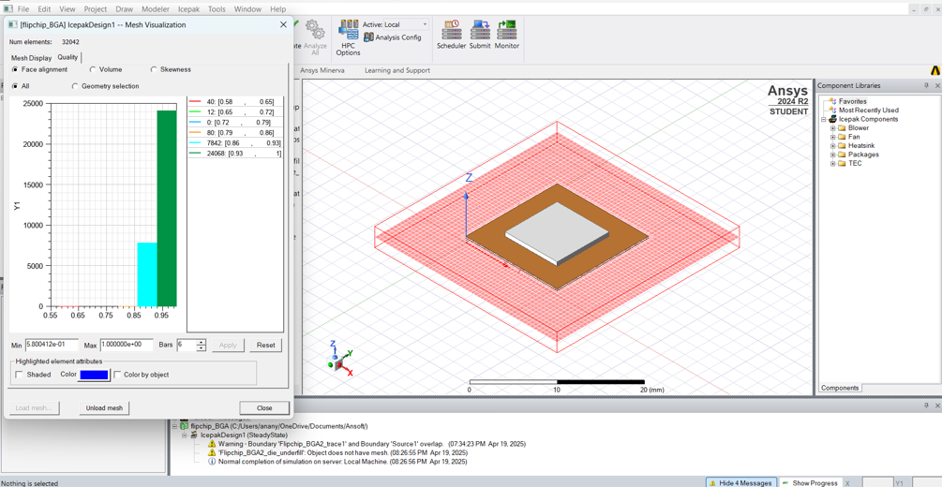

Similarly, check Skewness.

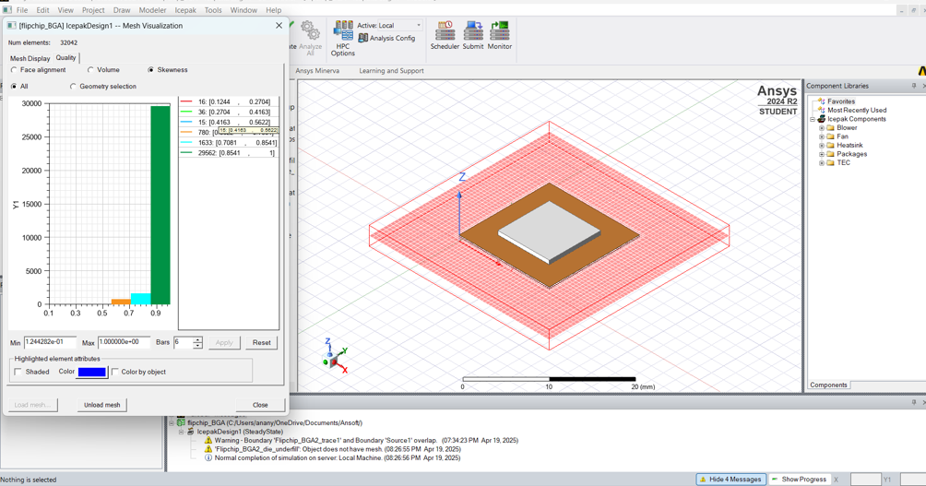

Go to Project Manager -> Analysis -> Add Solution Setup. A window will pop up. Click OK.

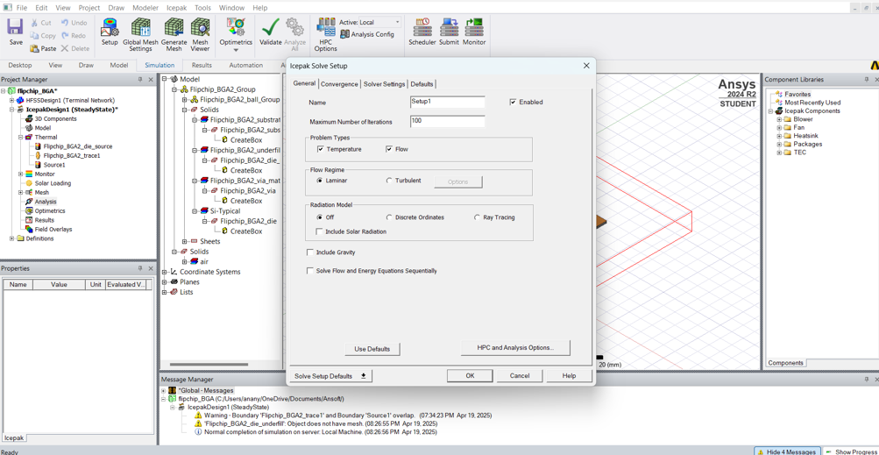

Click on Validate. If all the parameters have green ticks then there are no errors and you can proceed. 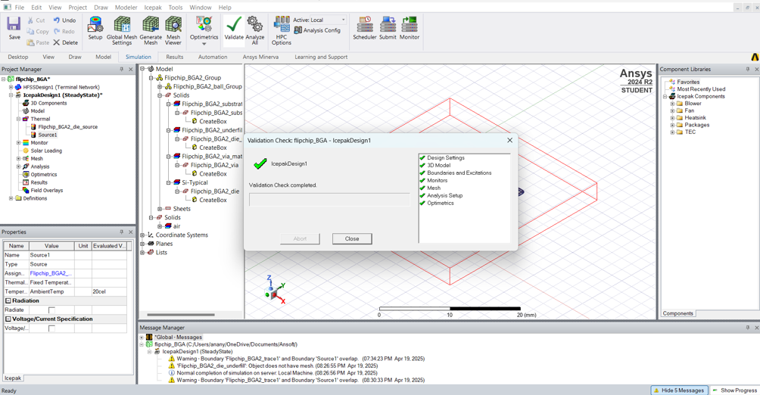

Click on Analyze All.

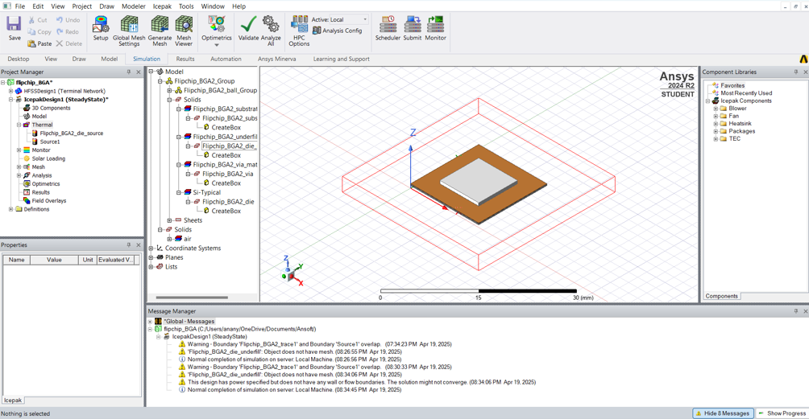

Go to Solids -> Flipchip_BGA2_die_underfill -> Assign Mesh Region -> select die -> OK -> again click OK on popped up window.

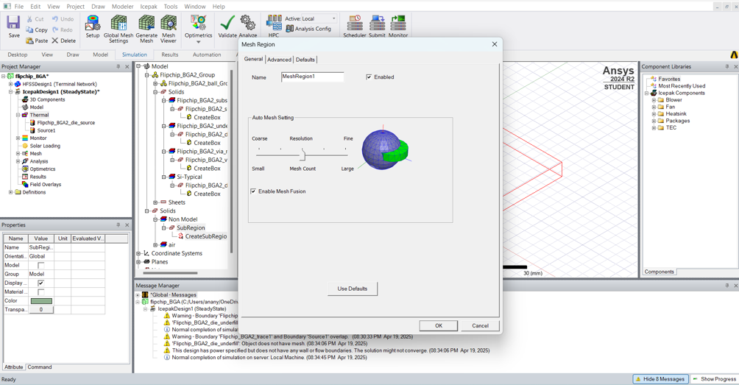

Select the package -> Plot Fields -> Temperature -> Temperature

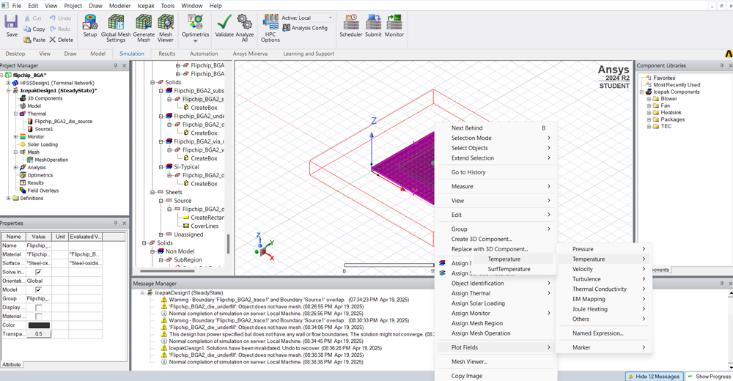

Click on Specify Name and Specify Folder, Select Plot on surface only and in Surface Smoothing, enable Guassian Smoothing and click Done.

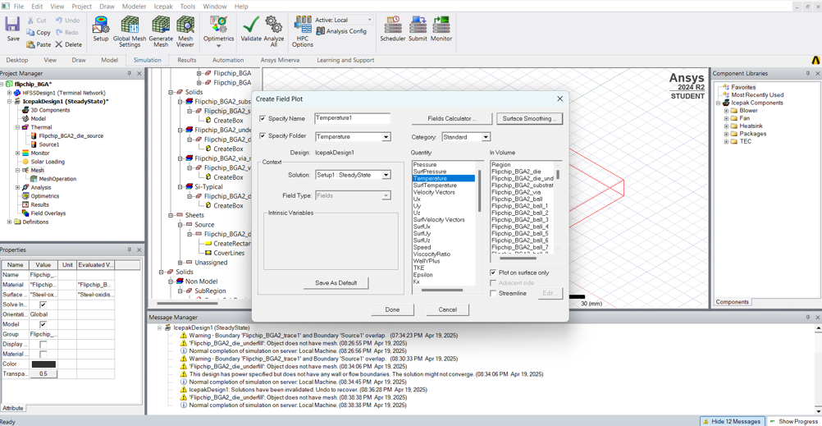

Thermal Analysis of the package is obtained.

